EXP NO 1:
CREATE A SIMPLE CLOUD SOFTWARE APPLICATION AND PROVIDE IT AS A SERVICE USING ANY CLOUD SERVICE PROVIDER TODEMONSTRATE SOFTWARE AS A SERVICE (SAAS).

AIM: To create a simple cloud software application and provide it as a service using any cloud service provider to demonstrate software as a service (saas).
procedure:
step1: go to zoho.com
step 2: login to the zoho.com
step 3: select one application
step 4: enter application name
step 5: created new application
step 6: select one form
step 7: the software has been created.
Output
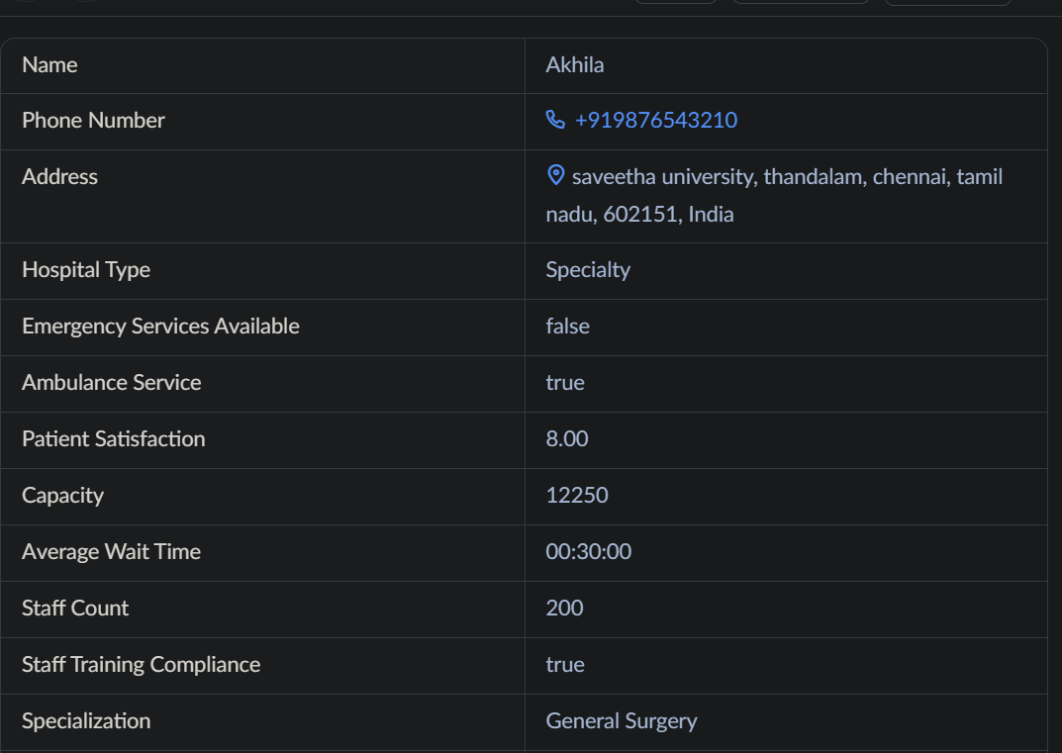

RESULT:
Successfully created a simple cloud software application and provide it as a service using any cloud service provider to demonstrate software as a service (SaaS).

